Design Patterns
Container Delivery Management System (CDMS)
University Metropolitan Tirana — Software Engineering Analysis & Design

Patterns Covered
Creational
• Factory Method
• Singleton
Structural
• Repository
• Facade
• Decorator
Behavioural
• Observer
• State
• Strategy
• Command

About this document
This document presents nine software design patterns applied to the Container Delivery Management System. Each pattern is described with its intent, the problem it solves in the context of CDMS, its solution, the participants involved, and the consequences of applying it. A UML class diagram accompanies each pattern.
Patterns are drawn from the Gang of Four (GoF) catalogue and organised into three categories: Creational (how objects are created), Structural (how objects are composed), and Behavioural (how objects communicate).

Creational Patterns
Creational patterns abstract the object creation process, making the system independent of how objects are created, composed, and represented.

1. Factory Method

Category | Creational
GoF Pattern | Factory Method (Virtual Constructor)
Module | Documents — Delivery Notes, Invoices, POD, Damage Checklists
Trigger | System needs to generate a document for a confirmed or delivered job
Benefit | Adding new document types requires no changes to existing code (OCP)

Intent
Define an interface for creating an object but let subclasses decide which class to instantiate. Factory Method lets a class defer instantiation to subclasses.

Problem in CDMS
The CDMS needs to generate several document types — Delivery Notes, Invoices, POD forms, and Damage Checklists. Without this pattern, a single class would need a large switch/if block to decide which document to create, coupling the creation logic tightly to every document type.

Solution
A DocumentCreator abstract class defines the createDocument() factory method. Each document type (DeliveryNoteCreator, InvoiceCreator, PODCreator) overrides this method and instantiates its own product. All products implement the Document interface, ensuring uniform handling.

Participants
• DocumentCreator — abstract creator declaring the factory method
• DeliveryNoteCreator, InvoiceCreator, PODCreator — concrete creators
• Document — product interface with generate(), export(), getTitle()
• DeliveryNote, Invoice, POD — concrete product implementations

Consequences
• Eliminates the need for if/else blocks when creating documents
• New document types added by creating a new creator subclass only
• Document generation logic is fully encapsulated per type
• Slightly more classes, but each has a single clear responsibility

UML Class Diagram
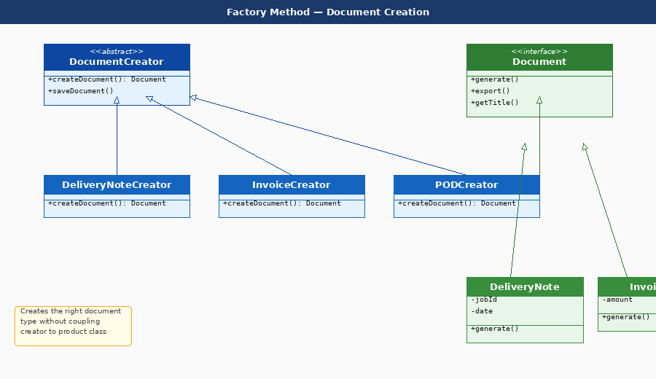
Figure — 1. Factory Method: UML class diagram showing CDMS-specific participants

2. Singleton

Category | Creational
GoF Pattern | Singleton
Module | Data Layer — all repository classes
Trigger | Any repository needs to execute a database query or transaction
Benefit | Prevents resource exhaustion; ensures consistent DB configuration

Intent
Ensure a class has only one instance and provide a global point of access to it.

Problem in CDMS
All repositories in CDMS (Job, Container, Driver, Invoice) need database access. Without Singleton, each repository would create its own connection, leading to resource exhaustion, inconsistent transactions, and configuration drift.

Solution
A DatabaseConnection class manages a single private static instance. All repository classes call DatabaseConnection.getInstance() which creates the connection on first call and returns the same instance thereafter. The constructor is private to prevent direct instantiation.

Participants
• DatabaseConnection — the singleton class with private constructor and getInstance()
• JobRepository, ContainerRepository, DriverRepository, InvoiceRepository — clients

Consequences
• Single connection instance shared across all repositories — no resource waste
• Centralised configuration and transaction management
• Easy to swap database driver by changing one class
• Must be thread-safe (getInstance must use locking in concurrent environments)

UML Class Diagram
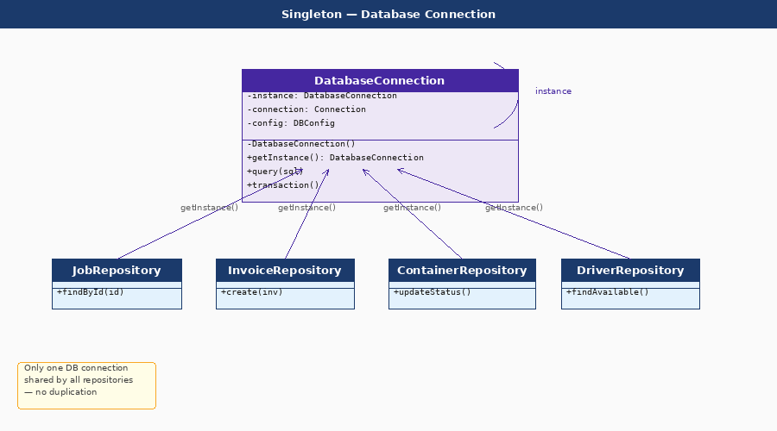
UML class diagram showing CDMS-specific participants

Structural Patterns
Structural patterns deal with object composition, creating relationships between objects to form larger structures while keeping them flexible and efficient.

3. Repository

Category | Structural (Data Access)
GoF Pattern | Repository (Domain-Driven Design pattern)
Module | All modules — Jobs, Containers, Drivers, Invoices, Documents
Trigger | Any service operation that reads or writes persistent data
Benefit | Clean architecture; business logic is DB-agnostic and testable

Intent
Mediate between the domain layer and the data mapping layer using a collection-like interface for accessing domain objects.

Problem in CDMS
Service classes like JobService need to store and retrieve entities (Jobs, Containers, Drivers). Without this pattern, SQL queries would be scattered throughout business logic, making the code hard to test and impossible to switch databases without major rewrites.

Solution
Each entity has a repository interface (IJobRepository, IContainerRepository, IDriverRepository) declaring data operations. Concrete SQL implementations (SqlJobRepository, etc.) handle the actual queries. Services depend only on interfaces, not SQL classes — enabling easy mocking in unit tests.

Participants
• IJobRepository, IContainerRepository, IDriverRepository — repository interfaces
• SqlJobRepository, SqlContainerRepository, SqlDriverRepository — SQL implementations
• JobService, DispatchService — service classes depending on interfaces
• DatabaseConnection (Singleton) — shared by all concrete repositories

Consequences
• Business logic contains zero SQL — fully separated concerns
• Repositories can be mocked for unit testing without a real database
• Switching from SQL to NoSQL only requires new concrete implementations
• Centralized data access rules (e.g. soft-delete, audit logging)

UML Class Diagram
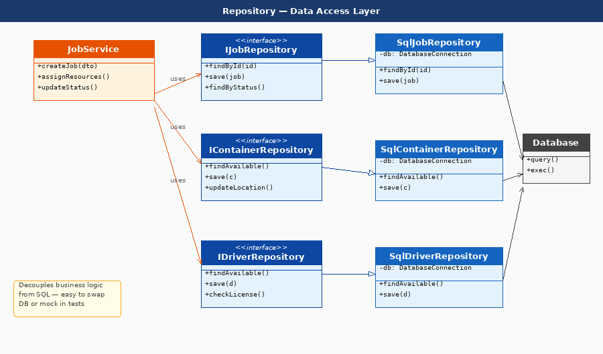
Figure — 3. Repository: UML class diagram showing CDMS-specific participants

4. Facade

Category | Structural
GoF Pattern | Facade
Module | Scheduling / Dispatch — job assignment workflow
Trigger | Dispatcher assigns resources and confirms a job
Benefit | Decouples controller from subsystems; reduces cognitive load

Intent
Provide a simplified interface to a complex subsystem, hiding its internal complexity from clients.

Problem in CDMS
The dispatch process involves many subsystems: scheduling, conflict checking, notifications, document generation, and multiple repositories. Without a Facade, the DispatchController would need to orchestrate all of these directly, creating deep coupling and bloated controller code.

Solution
A DispatchFacade class exposes three simple methods: assignResources(), validateAndConfirm(), and notifyDriver(). Internally it coordinates SchedulingService, ConflictChecker, NotificationService, DocumentService, and all relevant repositories. The controller calls one method and the facade handles the rest.

Participants
• DispatchFacade — the simplified interface hiding subsystem complexity
• DispatchController — client that calls the facade only
• SchedulingService, ConflictChecker, NotificationService, DocumentService — subsystems
• ContainerRepository, DriverRepository, TruckRepository — data subsystems

Consequences
• Controller code is clean — one call triggers a full dispatch workflow
• Subsystems can evolve independently without changing the controller
• Business workflow logic is centralised in one orchestration class
• Easier to write integration tests against the facade interface

UML Class Diagram
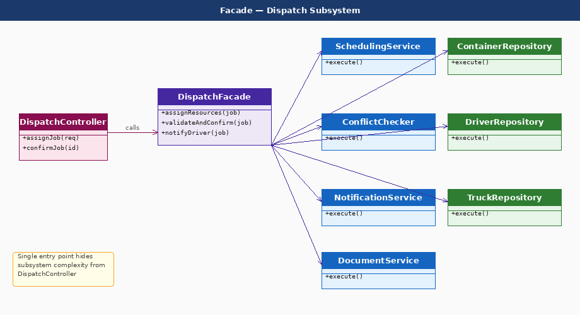
Figure — 4. Facade: UML class diagram showing CDMS-specific participants

5. Decorator

Category | Structural
GoF Pattern | Decorator (Wrapper)
Module | Reports — delivery, revenue, utilisation, unpaid invoices
Trigger | Management requests a filtered or formatted report
Benefit | Avoids class explosion; flexible composition at runtime

Intent
Attach additional responsibilities to an object dynamically. Decorators provide a flexible alternative to subclassing for extending functionality.

Problem in CDMS
Management needs delivery reports filtered by date, by customer, or exported as PDF — and sometimes all three at once. Without Decorator, every combination would need its own subclass (DateFilteredPDFReport, CustomerFilteredReport, etc.), causing an explosion of classes.

Solution
DeliveryReport implements the IReport interface. FilterByDateDecorator, FilterByCustomerDecorator, and ExportPDFDecorator all wrap an IReport and delegate to it, adding their behaviour before or after. Decorators can be stacked: new ExportPDFDecorator(new FilterByDateDecorator(new DeliveryReport())).

Participants
• IReport — component interface with generate() and export()
• DeliveryReport — concrete base report
• ReportDecorator — abstract decorator holding a wrapped IReport
• FilterByDateDecorator, FilterByCustomerDecorator, ExportPDFDecorator — concrete decorators

Consequences
• New filters or export formats added without touching existing report classes
• Decorators compose at runtime — any combination supported
• Each decorator has a single responsibility
• Stacked decorators can complicate debugging if overused

UML Class Diagram
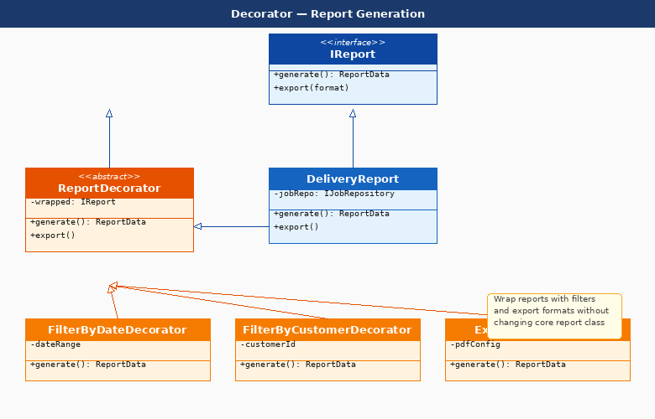
Figure — 5. Decorator: UML class diagram showing CDMS-specific participants

Behavioural Patterns
Behavioural patterns characterise the ways in which classes or objects interact and distribute responsibility.

6. Observer

Category | Behavioural
GoF Pattern | Observer (Event/Listener, Pub-Sub)
Module | Jobs — status changes; Invoices — auto-trigger; Notifications
Trigger | Job status changes: Confirmed, Assigned, In Transit, Delivered
Benefit | Loose coupling between job lifecycle and downstream reactions

Intent
Define a one-to-many dependency between objects so that when one object changes state, all its dependents are notified and updated automatically.

Problem in CDMS
When a job status changes (e.g. to Delivered), multiple things must happen: the driver must be notified, an invoice must be triggered, and the event must be logged for audit. Without Observer, JobService would need to call each of these directly, tightly coupling it to notification, invoicing, and audit subsystems.

Solution
JobEventPublisher maintains a list of IEventListener subscribers. When job status changes, it publishes a JobEvent. DriverNotifier, InvoiceAutoTrigger, and AuditLogger each implement IEventListener and react to the relevant event type. JobService only depends on the publisher.

Participants
• IEventPublisher — subject interface with subscribe/unsubscribe/publish
• JobEventPublisher — concrete subject maintaining listener list
• IEventListener — observer interface with onEvent(JobEvent)
• DriverNotifier, InvoiceAutoTrigger, AuditLogger — concrete observers
• JobEvent — value object carrying event type and job data

Consequences
• JobService is fully decoupled from notification, invoicing, and logging
• New reactions to job events added without modifying JobService
• Event system can be extended to email, SMS, or webhook listeners
• Must handle observer errors gracefully to avoid blocking the publisher

UML Class Diagram
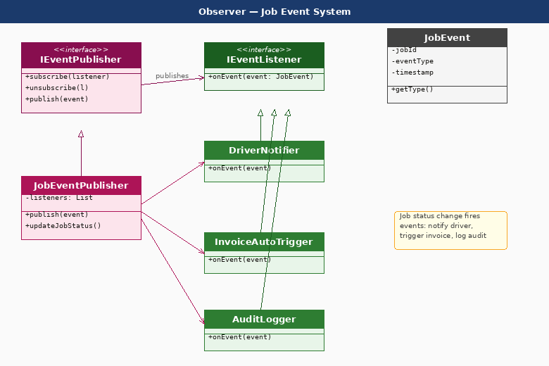
Figure — 6. Observer: UML class diagram showing CDMS-specific participants

7. State

Category | Behavioural
GoF Pattern | State
Module | Jobs — lifecycle management (7 states + Cancelled)
Trigger | Any action that changes job status (confirm, assign, deliver, invoice)
Benefit | Eliminates status-checking conditionals; enforces valid transitions

Intent
Allow an object to alter its behaviour when its internal state changes. The object will appear to change its class.

Problem in CDMS
A job passes through Draft → Confirmed → Assigned → In Transit → Delivered → Closed → Invoiced states. Without State pattern, the system would use if/switch statements throughout to check the current status before every operation, leading to fragile, duplicated guard logic that is hard to extend.

Solution
Each job status is represented as a State class (DraftState, ConfirmedState, etc.) implementing a IJobState interface. The Job object delegates actions (confirm(), assign(), markDelivered()) to its current state. Each state class knows which transitions are valid and throws an error for invalid ones.

Participants
• IJobState — state interface with all lifecycle action methods
• DraftState, ConfirmedState, AssignedState, InTransitState, DeliveredState, ClosedState, InvoicedState, CancelledState — concrete states
• Job — context that holds current state and delegates actions to it

Consequences
• Each state class encapsulates its own transition rules — no scattered conditionals
• Invalid transitions are caught at the state level, not scattered across services
• New states added by creating a new state class only
• Clear documentation of the full job lifecycle in code

UML Class Diagram
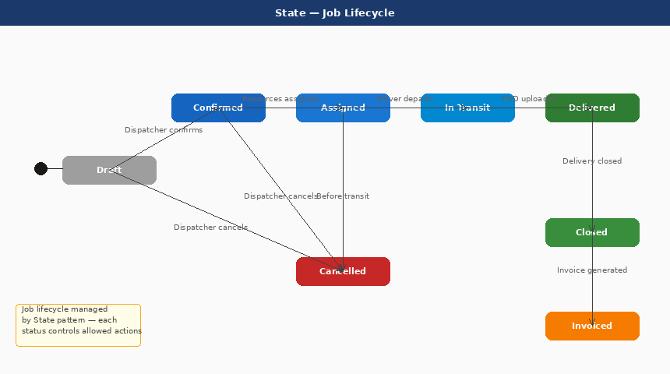
Figure — 7. State: UML class diagram showing CDMS-specific participants

8. Strategy

Category | Behavioural
GoF Pattern | Strategy (Policy)
Module | Invoices & Payments — pricing calculation per customer contract
Trigger | Accountant generates an invoice for a delivered job
Benefit | Pricing algorithms are interchangeable and independently testable

Intent
Define a family of algorithms, encapsulate each one, and make them interchangeable. Strategy lets the algorithm vary independently from clients that use it.

Problem in CDMS
Different customers have different pricing agreements: flat rate per job, distance-based, weight-based, or custom contract rates. Without Strategy, InvoiceCalculator would have a long if/else chain checking customer type, making it hard to add new pricing models or test individual algorithms.

Solution
IPricingStrategy defines the calculate(job) method. FlatRatePricing, DistancePricing, WeightPricing, and ContractPricing each implement this interface. InvoiceCalculator holds an IPricingStrategy and delegates calculation to it. The correct strategy is injected at runtime based on the customer contract.

Participants
• IPricingStrategy — strategy interface with calculate(job): Money
• FlatRatePricing, DistancePricing, WeightPricing, ContractPricing — concrete strategies
• InvoiceCalculator — context that uses an IPricingStrategy

Consequences
• New pricing models added without changing InvoiceCalculator
• Each pricing algorithm is independently testable
• Strategy selected at runtime based on customer contract data
• Eliminates if/else pricing chains in the invoice generation code

UML Class Diagram
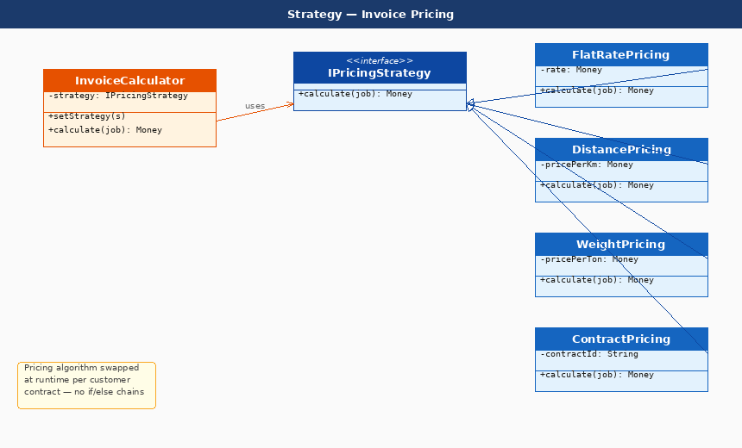
Figure — 8. Strategy: UML class diagram showing CDMS-specific participants

9. Command

Category | Behavioural
GoF Pattern | Command (Action, Transaction)
Module | Jobs, Scheduling, Invoices — all critical write operations
Trigger | Any create, assign, update, or generate operation in the system
Benefit | Full audit log, undo support, and async queue capability

Intent
Encapsulate a request as an object, thereby letting you parameterise clients with different requests, queue or log requests, and support undoable operations.

Problem in CDMS
Key operations in CDMS (creating jobs, assigning resources, updating status, generating invoices) need to be audited, queued during high load, and potentially undone (e.g. reverting a wrong assignment). Without Command, these operations are direct method calls with no history or reversibility.

Solution
Each operation is wrapped in a Command class (CreateJobCommand, AssignResourcesCommand, UpdateStatusCommand, GenerateInvoiceCommand) implementing ICommand with execute() and undo(). A CommandBus queues and dispatches commands, logging each one. Commands call into JobService as the receiver.

Participants
• ICommand — command interface with execute() and undo()
• CreateJobCommand, AssignResourcesCommand, UpdateStatusCommand, GenerateInvoiceCommand — concrete commands
• CommandBus — invoker that queues and dispatches commands
• JobService — receiver that carries out the actual business logic

Consequences
• All operations are logged automatically as command objects
• Operations can be queued and executed asynchronously
• Undo support for critical operations (e.g. revert a wrong resource assignment)
• Commands can be serialised for audit trails or replayed after failures

UML Class Diagram
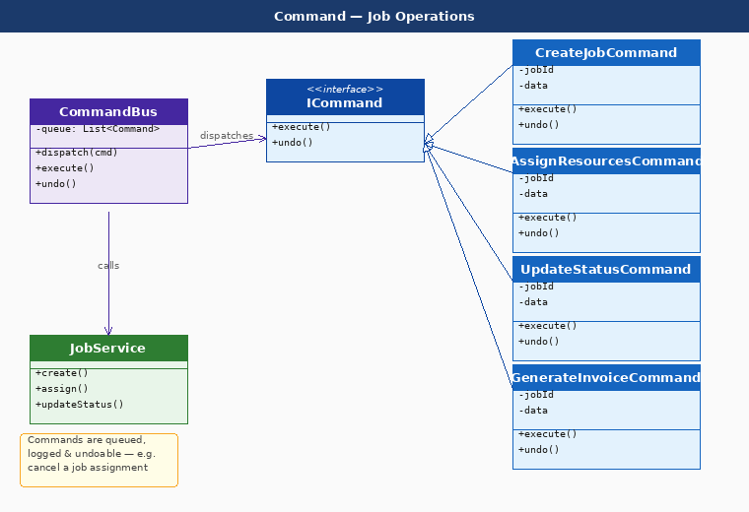
Figure — 9. Command: UML class diagram showing CDMS-specific participants

